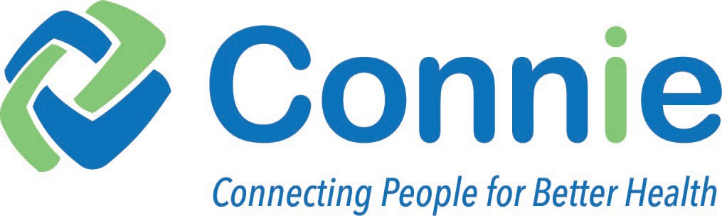
PATIENT NOTICE

Your health care provider has agreed to participate in Connie, the Connecticut state-wide Health Information Exchange (HIE). Connie provides the fast and secure exchange of health information among doctors’ offices, hospitals, labs, radiology centers, and other healthcare organizations. Connie allows health care providers and organizations coordinating care to view their patient’s or client’s medical history.

WHO WILL HAVE ACCESS TO MY HEALTH RECORD?

Only users specifically authorized by Connie and its participating organizations can access data through HIE. Any user accessing health information through Connie must have a specific reason to do so, such as providing treatment to the person whose health information they are accessing.

WHAT INFORMATION IS IN MY ELECTRONIC MEDICAL RECORD?

Your health care provider uses an electronic medical record to keep track of the treatment provided to you. This electronic record may include your…

- medical history
- lab and imaging results
- medications
- allergies
- known drug reactions
- doctor’s and nurse’s notes

Connie does not have a complete record of your health history. It is simply a way for your health care providers to access the health information they need to provide you with the best possible care.

WHAT ABOUT MY SENSITIVE HEALTH RECORDS?

Federal and State laws protect the privacy of certain kinds of medical records. These include…
- drug or alcohol abuse treatment records
- psychotherapy notes
- goods and services that you have paid for out-of-pocket and request to keep private
When required by law, your consent will be obtained before Connie will allow the sharing of your sensitive health records.

WHAT ARE THE BENEFITS TO ME?

A Health Information Exchange makes healthcare delivery seamless and effective, ensuring that providers and care teams have the vital tools and clinical data resources they need at the point of care to improve patient outcomes while keeping patient data secure. For example, if a patient is in an emergency room and unable to answer questions, the doctor or nurse could check Connie to make sure the patient doesn’t have allergies or medical conditions that would affect their treatment.

A Health Information Exchange may also lower health care costs by helping to prevent repeated tests because doctors can check Connie to see results from previous tests or labs.

ARE THERE PRIVACY RISKS AND HOW IS MY PRIVACY PROTECTED?

Doctors, hospitals and anyone else who is treating you are already responsible for keeping your health records private. The only added risk is that your health record will now be seen through the computer rather than by mail or fax. Careful records are kept on any health information accessed through Connie. All participating health organizations must sign a legally binding document that identifies the extensive requirements for privacy, confidentiality and security of the information accessible through Connie.

Connie also uses modern technology to keep your health records private and safe. Connie
protects your privacy by…

- encrypting your health record so only the people who need to see it can
- requiring use of passwords
- tracking who looks at your health record through Connie

DO I HAVE TO PARTICPATE IN CONNIE?

To allow your health record to be shared through Connie you do not need to take action.
If you do not wish to participate you must Opt-out. Opting-out means that doctors and other health care providers will not be able to access your health record through Connie. You have several options for opting out of Connie. You may visit the Connie website at www.conniect.org or ask your health care provider for a Request to Opt-Out form.

IF YOU CHOOSE NOT TO PARTICIPATE (OPT-OUT):

Connie will keep your personal information (name, address, birth date, etc.) on file in its Master Patient Index to permanently record your decision to opt-out.
Your doctor or health care provider will still be able to use Connie to report and/or view…

  - communicable diseases
  - immunization data
  - quality reports
  - other required public health information to state and federal agencies.
  - dispensed controlled substances

It is important to understand that choosing to opt-out of Connie does not mean your health information cannot be shared electronically. Health care providers may use other electronic methods such as secure email or electronic lab results delivery to share patient information. Read your health care provider’s notice of privacy practices for more information.

IF I HAVE CHOSEN TO OPT-OUT CAN I CHANGE MY MIND?

If you have previously submitted a Request to Opt-Out, you can change your mind at any time. To opt back in, call Connie's Customer Care Tea at 866-987-5514.

Please talk to your health care provider if you have questions about Connie or visit our website at www.conniect.org.

1.888.783.4410 • help@conniect.org • www.conniect.org

Connie March 2021

